7. Scope Definition – In-Scope
The following features are in-scope for the School ERP Management System:
- User Management
Role-based access for Admin, Teacher, Student, and Parent.
- Student Management
Admission process, student profiles, academic records, and class allocation.
- Attendance Module
Daily attendance marking by teachers and viewing access for students and parents.
- Examination & Marks Management
Marks entry by teachers and automatic report card generation.
- Timetable Management
Class-wise timetable creation and viewing.
- Fee Management
Fee structure definition, payment tracking, and receipt generation.
- Communication Module
Announcements, notices, and alerts for students and parents.
- Dashboard & Reports
Performance summaries, attendance reports, and fee reports.
- Data Security & Backup
Secure login, data encryption, and regular data backups.

8. Scope Definition – Out-of-Scope
The following features are out-of-scope for the current version:
- Mobile application development (only responsive web-based system).
- Online payment gateway integration (offline fee tracking only).
- Biometric attendance system (manual digital entry only).
- Library Management System.
- Transport Management System.

9. Scope Boundaries Document
Project Name: School ERP Management System
Version: 1.0

Objective
To digitize and integrate core academic and administrative functions into a unified platform.

Inclusions
- Modules:
User, Student, Attendance, Marks, Timetable, Fees, Communication, Reports.
- Users:
Students, Teachers, Admin, Principal, IT Admin.
- Platform:
Web-based system with role-based access and centralized database.

Exclusions
- Mobile application
- Online payment gateway
- Biometric systems
- Library management
- Transport management
- HR & payroll
- Live chat or video conferencing

Assumptions
- The school has basic IT infrastructure and internet connectivity.
- Users possess basic digital literacy.
- Initial data migration from existing records will be manual.

10. Software Requirements Specification (SRS) – Introduction

1.1 Purpose
This document describes the functional and non-functional requirements for the School ERP Management System, a web-based platform designed to streamline school operations.

1.2 Scope
Refer to Sections 7, 8, and 9 for detailed scope definitions.

1.3 Definitions, Acronyms, and Abbreviations
- ERP – Enterprise Resource Planning
- SRS – Software Requirements Specification
- FR – Functional Requirement
- NFR – Non-Functional Requirement
- UI – User Interface
- API – Application Programming Interface

11. SRS – Overall Description

2.1 Product Perspective
The system is a standalone, web-based application with role-based dashboards.

2.2 Product Functions
- User authentication and authorization
- Student and staff data management
- Attendance and marks entry
- Timetable and fee management
- Notifications and report generation

2.3 User Characteristics
- Admins: Technically proficient; manage system operations.
- Teachers: Basic computer skills; require simple data entry interfaces.
- Students & Parents: Access academic information through a simple UI.

2.4 Constraints
- Must support common browsers (Chrome, Firefox).
- Must comply with data privacy regulations.
- No real-time online payment processing in Version 1.

12. Functional Requirements

FR-01: User Registration & Login
- Users can log in using valid credentials.
- Password reset functionality is available.
Acceptance Criteria:
Login should be successful within 2 seconds.

FR-02: Attendance Marking
- Teachers can mark daily attendance for each class.
- Admin can view attendance reports.
Acceptance Criteria:
Attendance data is saved immediately with no data loss.

FR-03: Marks Entry & Report Generation
- Teachers can enter subject-wise marks.
- System generates report cards automatically.
Acceptance Criteria:
Report cards are downloadable in PDF format.

FR-04: Fee Management
- Admin defines fee structures.
- Parents can view fee dues and payment history.
Acceptance Criteria:
Accurate calculation and display of fee dues.

FR-05: Timetable Management
- Admin creates class-wise timetables.
- Students and teachers can view timetables on dashboards.
Acceptance Criteria:
Timetables display correctly without errors.

FR-06: Announcements
- Admin and teachers can post announcements.
- Notifications are visible to relevant users.
Acceptance Criteria:
Announcements are delivered immediately.

13. Non-Functional Requirements

NFR-01: Performance
- Support up to 500 concurrent users.
- Page load time should be less than 3 seconds.

NFR-02: Security
- Role-based access control implemented.
- Data encrypted both in transit and at rest.

NFR-03: Usability
- Intuitive user interface requiring minimal training.
- Responsive design for desktops and tablets.

NFR-04: Reliability
- System uptime of 99%.
- Automated daily backups.
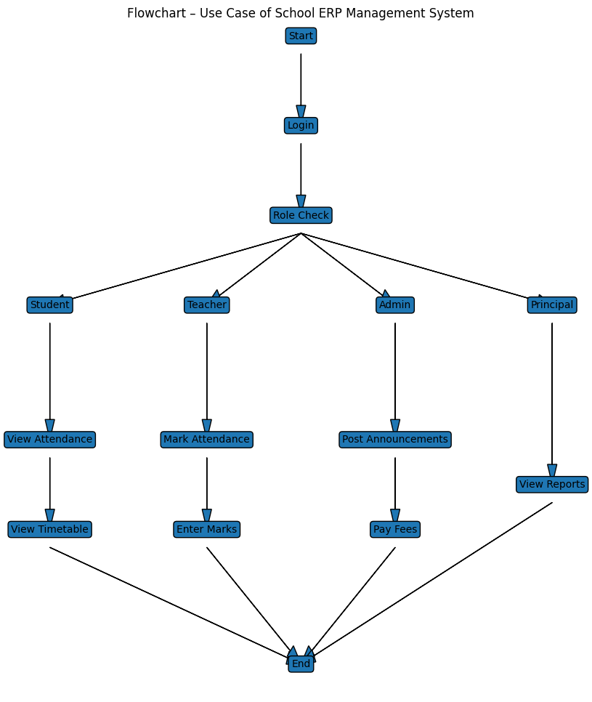

14. Use Case
Actors:
- Student
- Teacher
- Admin
- Principal
Use Cases:
- Login
- View Attendance
- Mark Attendance
- Enter Marks
- View Reports
- Pay Fees
- View Timetable
- Post Announcements

15. Glossary
- Admission Number: Unique identification number assigned to each student.
- Attendance Percentage:
$$(PresentDays÷TotalWorkingDays)×100$$
- Fee Dues: Outstanding unpaid fee amount.
- Report Card: Document showing a student’s marks or grades.
- Timetable: Schedule of classes for a day or week.

